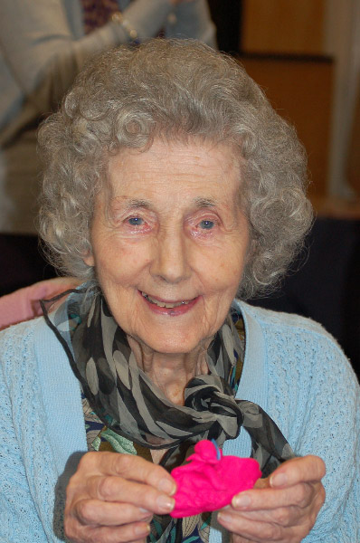Feeling creative?

In partnership with 64 Million Artists Derby Parkinson’s branch are offering a free creative project for anyone wanting to get involved.   
Creativity can help keep your mind active, improve your wellbeing and support you to make good connections with people. It’s also fun, easy to do, and something that can be designed around what you want to do or learn. This project will be part of an East Midlands wide initiative to get older people taking part in creative activities, and part of a national project to unlock the creativity in everyone.

The group will meet weekly and be set different creative tasks and challenges to complete. These will always be fun, free to do and will involve lots of different kinds of things (drawing, writing, making, thinking, talking etc) so whatever you enjoy there will be something to suit you. We’ll also be encouraging you to learn from each other, and bring ideas to share. Throughout the week you can then (if you like) also pick up extra little challenges to do  at home or with friends or family, they will only take 10 or 15 mins and are completely optional, but they’re a way of practising your creativity throughout the week. We’ll be encouraging groups to also post about what they’ve been doing on the projects website, to share with friends and family or the wider world ,if they want to.   
  
Although the project is being offered to the Parkinson’s group - it is open to anyone so if you’d like to bring friends or family members along too that’s fine. **The sessions will be taking place weekly on Mondays from 10.30 -12pm in the Aston Court Hotel. The first session is 15 May.**

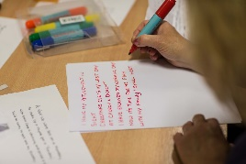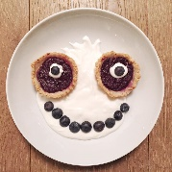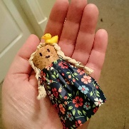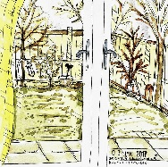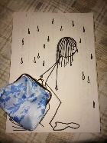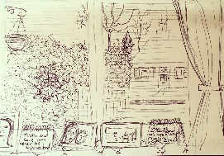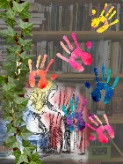 **If you are interested in taking part call 01332 515700**

Derby Shining Stars

We’re delighted to announce the finalists for the UK Parkinson’s Excellence Network Awards – the Awards recognise and celebrate outstanding health and social care services that make a difference to people affected by Parkinson's.

The [Excellence Network](https://www.parkinsons.org.uk/professionals) Awards ceremony was held 6 March, hosted by renowned journalist and broadcaster John Stapleton.

There were highly commended mentions for the Parkinson's Service at Derby Teaching Hospitals NHS Foundation Trust – for their work to adapt their services according to patient feedback.